Below is the Android email template to adding the Exchange Outlook account to your device. This will include your Outlook email, contacts, & calendar. Feel free to reach out to the Mobility Team if you have issues with the setup of email on your device.

Below is the basic login info and below are the step by step instructions with screenshots.

MCD Oversight

GENERIC EXCHANGE ACTIVE SYNC SETTINGS

|  |  |
| --- | --- |
| **Your Email Address** | [**John.Doe@nissan-usa.com**](mailto:John.Doe@nissan-usa.com) |
| **Server Address** | webmail.na.nissan.biz |
| **Domain\LAN ID** | nmcorp\doej **OR** nmcorp\x123456 |
| **Your Password** | ******** |

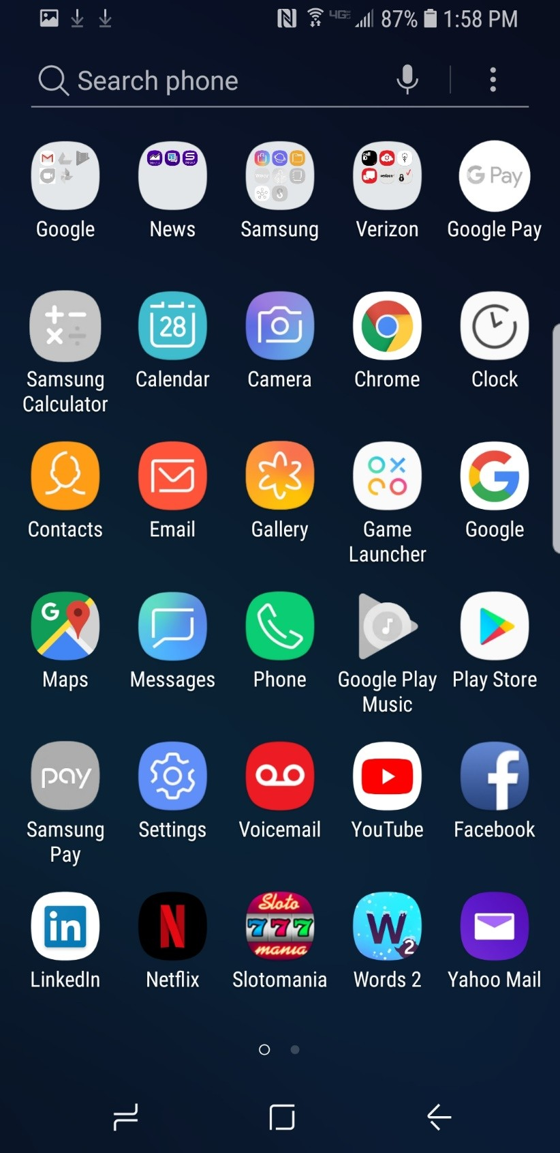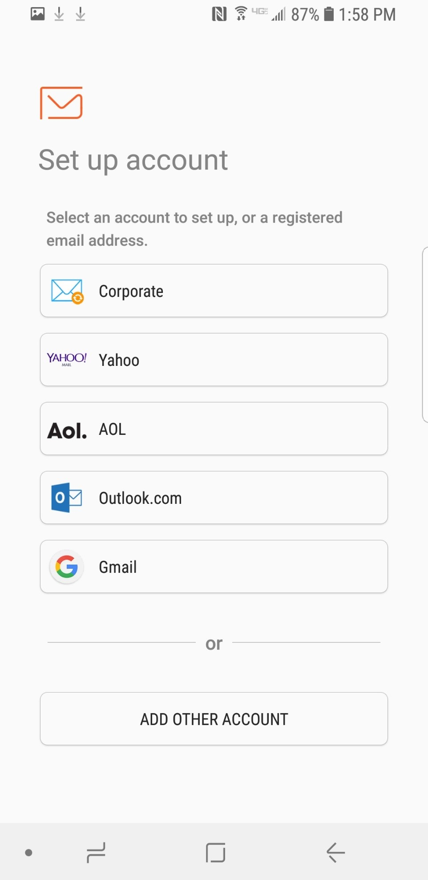

Step 1: Go through your email app to enter your initial information.

You can also go through your settings and go to Accounts and add email through this as well



Step 2: Click add other account since exchange is not listed

Step 3: Input your corporate email address as well as your email/ windows sign in password

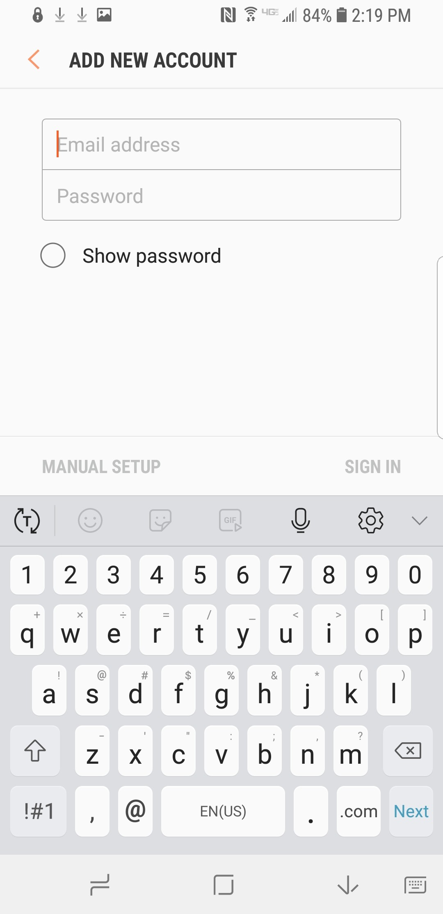

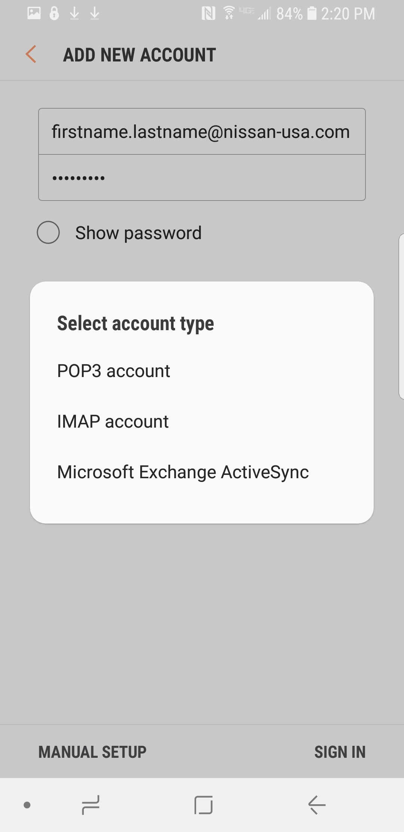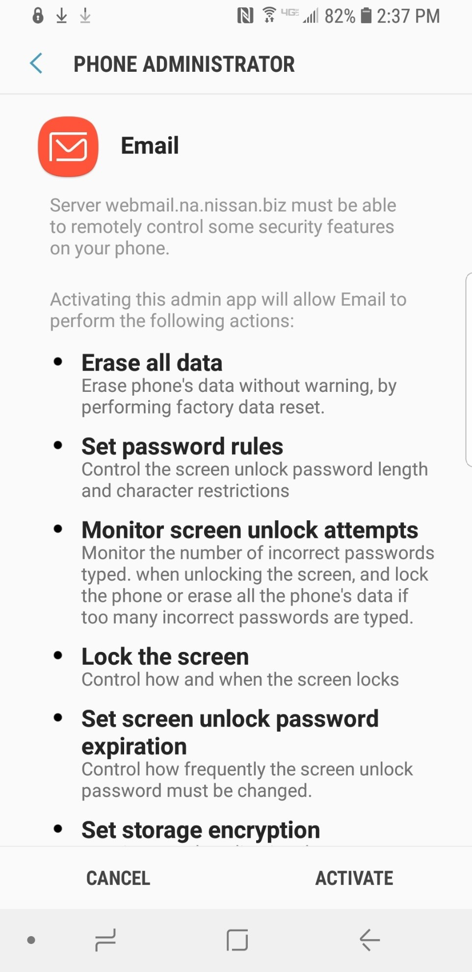

Step 4: After entering your information select Manual Setup

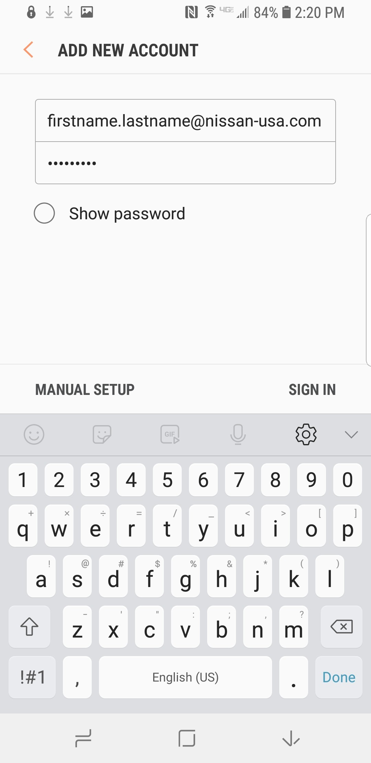

Step 5: Select Microsoft Exchange ActiveSync

Step 7: Under server settings enter webmail.na.nissan.biz

Make sure Use Secure Connection (SSL) is enabled before selecting next

Step 6: Under account enter your Corporate Nissan Email Address. Second, under domain enter nmcorp\ X ID or Lan ID. Third, enter your email/ windows sign in password.

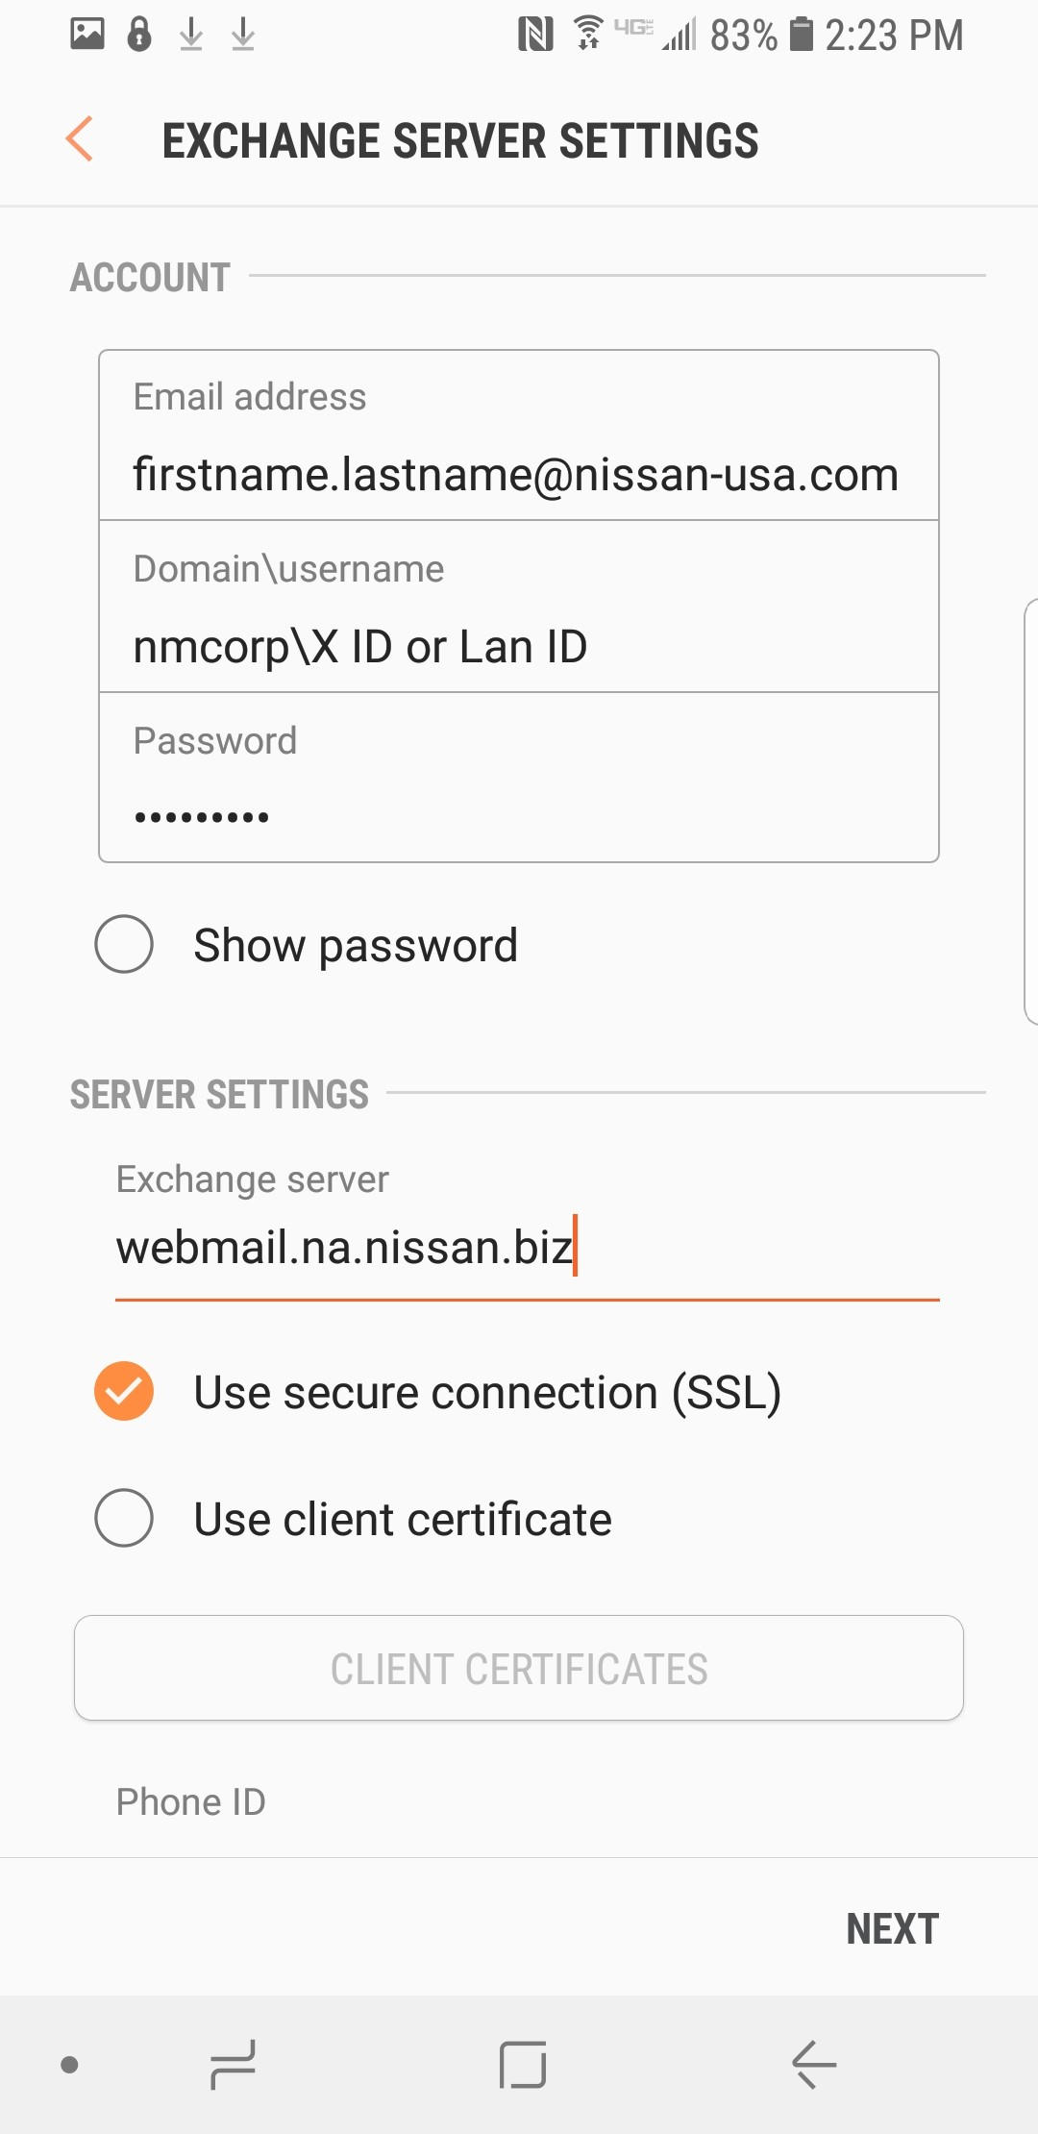

Step 8: Make sure you apply the Remote Security Administration settings for Nissan. If not this will time out your session.

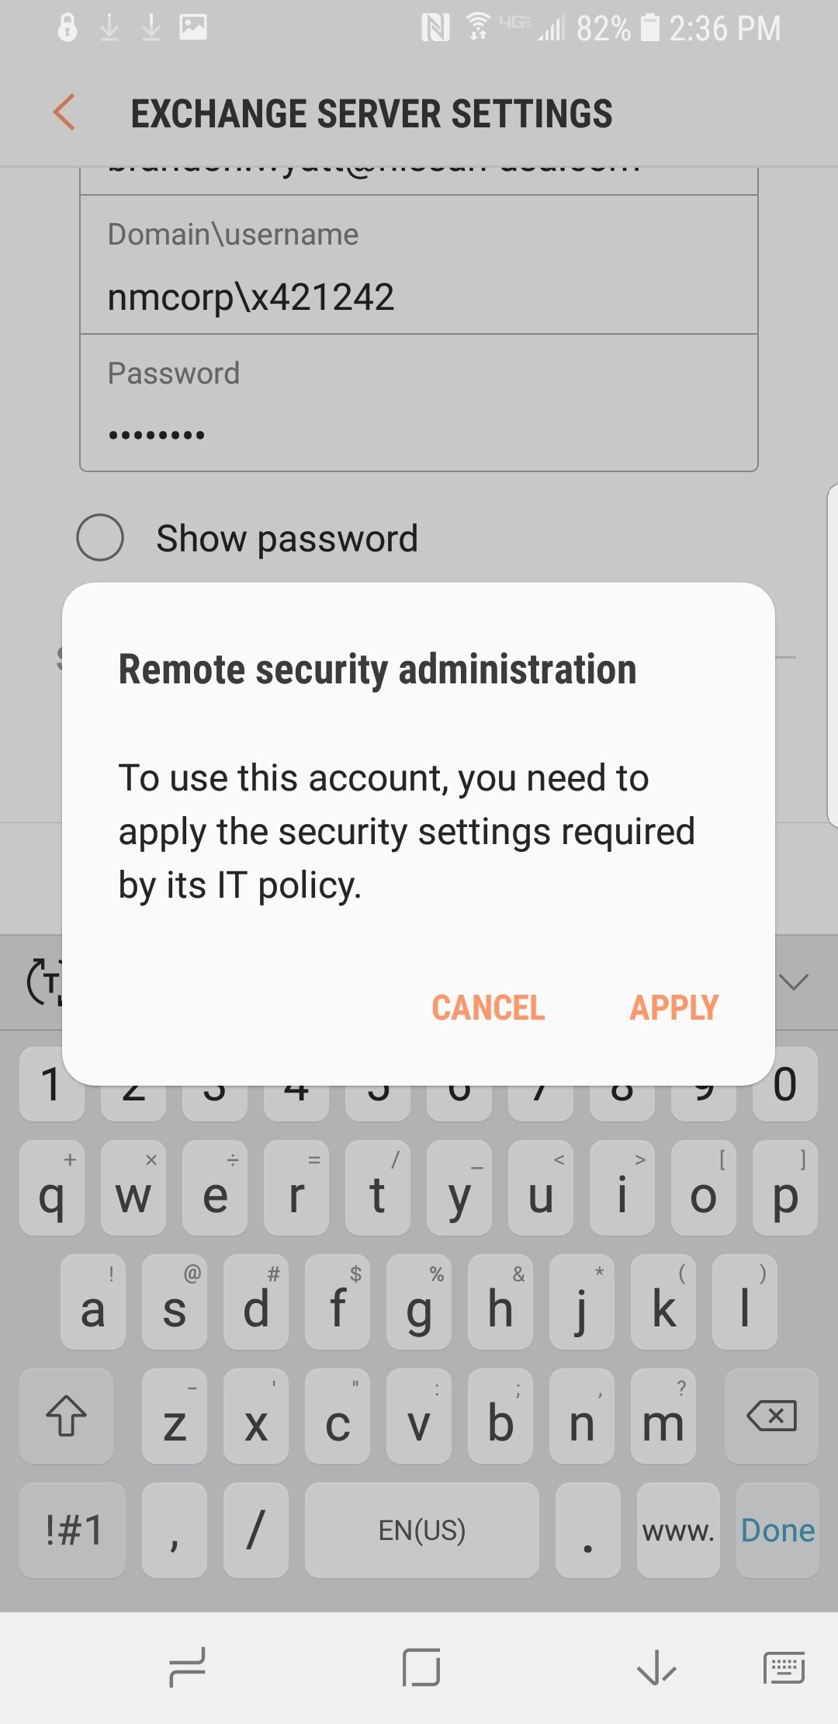

Step 9: Once you have applied the settings, you hit activate and if everything has been entered properly you will start receiving emails.

Step 10: This is the final portion of the setup process. From here you can name the email account whatever you choose and hit done and you are ready to start checking your email.

